**Super Terminal Expo Facilitating Intermodal Synergies and Future-Forward Design for Asia's Transportation Hubs**

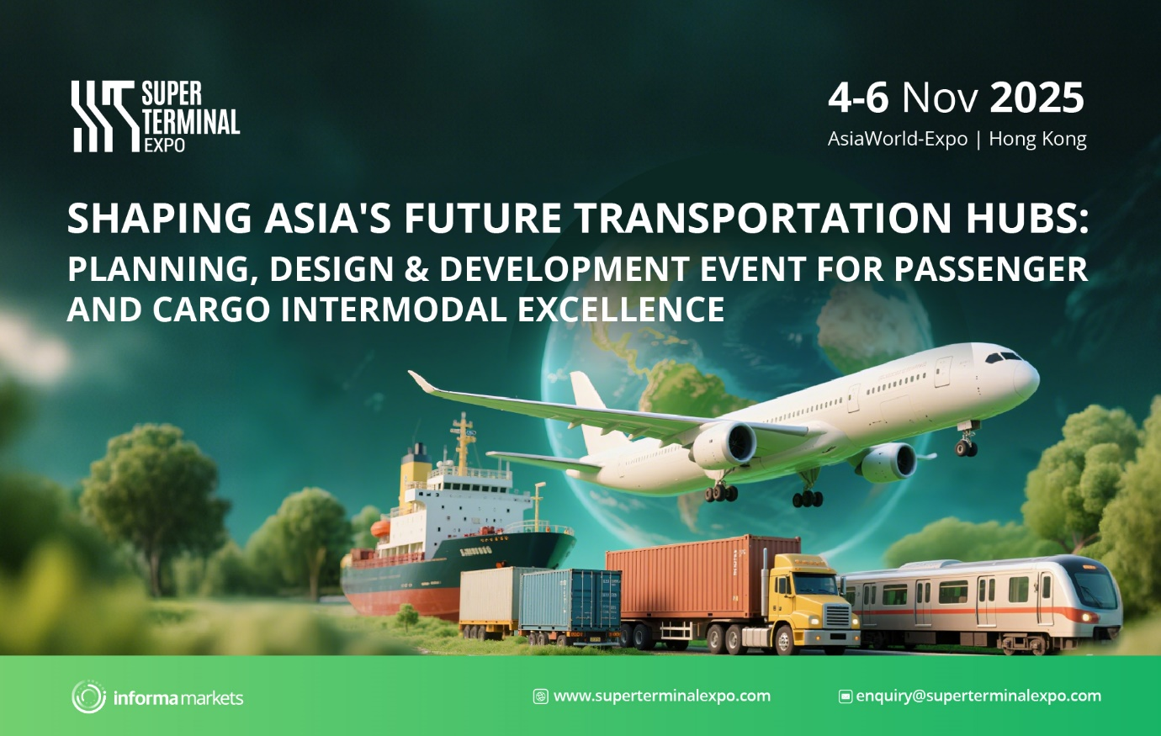

**HONG KONG, 24 Apr 2025** - The planning, design and development of efficient, accessible intermodal transportation hubs, particularly at airports, will take centre stage this November 4 - 6 at AsiaWorld-Expo in Hong Kong for the Super Terminal Expo.

Backed by Hong Kong International Airport, Super Terminal Expo reinforces its positioning as a comprehensive platform that engages industry leaders and professionals in the design & development of intermodal transportation hubs. Recognising the fundamental role of efficient intermodal connections in modern transportation for both passengers and cargo, Super Terminal Expo will be the key event in Asia for insights and innovation in this vital field.

The event will showcase the latest innovations and future trends in **terminal design, airport construction, and master planning**, featuring insights from leading architects, planners, and construction experts. The expected 4,000+ attendees will also explore cutting-edge solutions for **passenger and cargo ground operations, smart terminal automations, and AI-enhanced cargo management**, as well as advancements in **rail and metro integration within intermodal hubs**. A strong emphasis will be placed on sustainable practices and fostering industry collaboration.

**Airport Dialogues: Aviation at the Forefront**

The event will feature a prominent series of roundtable discussions titled 'Airport Dialogues”, bringing together academics, industry practitioners, and policymakers to address pressing challenges in airport design and development.

**Stella Fung, General Manager – Maritime & Aviation, Informa Markets**, emphasised the importance of these discussions in shaping the future of airport design and development. "Our aim is to foster collaboration between various stakeholders to tackle the complex challenges facing modern airports and ensure they remain efficient, sustainable, and passenger-friendly in an ever-evolving aviation landscape," she explained.

Attendees will have the opportunity to participate in focused dialogues, including:

**Planning the Airport City of Tomorrow:** This crucial roundtable will delve into the strategic development of airport cities, exploring vital elements such as land-use optimisation and zoning strategies, methods for enhancing intermodal connectivity (rail, road, public transport), and approaches to creating sustainable and liveable environments within the airport city framework. Participants will collaborate to identify best practices and innovative solutions for building thriving airport ecosystems.

**Driving Efficiency in Ground Operations: The Role of Infrastructure and Technology:** This session will explore cutting-edge strategies for optimising airport ground operations to achieve enhanced efficiency and safety. Key discussion points will include leveraging technology and automation for significant efficiencies, methods for improving apron management and aircraft turnaround times, and the identification of necessary infrastructure adaptations and upgrades to support more efficient ground operations and the seamless adoption of new technologies.

**Exclusive Behind-the-Scenes Tours of Hong Kong International Airport:** Attendees will have the exclusive opportunity to participate in behind-the-scenes tours of Hong Kong International Airport's latest developments, offering a unique chance to witness best practices firsthand and gain a deeper understanding of the complexities and innovations driving a world-class airport.   
  
These exclusive tours have limited availability and will be offered to selected hosted buyers, with further details regarding scheduling and invitations to be announced closer to the event.

**Professionals interested in shaping the future of Asia's transportation hubs are encouraged to learn more about Super Terminal Expo.**  
  
To Exhibit: [https://www.superterminalexpo.com/exhibitors](https://www.superterminalexpo.com/exhibitors/?utm_medium=Website&utm_source=eDM&utm_campaign=202511STE_VP_pr3_intermodel&utm_content=GAD)

To Visit: [https://www.superterminalexpo.com/new-landing-2025](https://www.superterminalexpo.com/new-landing-2025/airports/?utm_medium=Website&utm_source=eDM&utm_campaign=202511STE_VP_pr3_intermodel&utm_content=GAD)

To Be a Hosted Buyer: [https://www.superterminalexpo.com/hosted-buyer-program](https://www.superterminalexpo.com/hosted-buyer-program/?utm_medium=Website&utm_source=eDM&utm_campaign=202511STE_VP_pr3_intermodel&utm_content=GAD)

**About Super Terminal Expo**

Super Terminal Expo is a three-day event held on November 4 - 6, at AsiaWorld-Expo in Hong Kong. It focuses on intermodal terminal design & development, exploring the unique challenges and opportunities in intermodal transportation hubs, with a focus on airports. Expecting more than 4,000 attendees, the event offers a comprehensive platform encompassing a dynamic **exhibition** showcasing the latest innovations from more than 120+ exhibitors and brands, an insightful **conference** featuring expert presentations and thought leadership, interactive **airport dialogues** fostering in-depth discussions, and a prestigious **awards** ceremony recognising industry excellence. Attendees will also benefit from valuable **networking opportunities** to connect with peers and leaders, and gain exclusive behind-the-scenes **tours of Hong Kong International Airport.**   
  
Co-location with GAD Asia  
For airport planners, operators, investors, and government reps, the co-location of GAD Asia at Super Terminal Expo in Hong Kong offers a prime opportunity. GAD Asia unites airport finance, management, and strategy leaders. This synergy provides a 360-degree view of future airport hubs, connecting you with global development stakeholders to identify investments and best practices for Asia's next-gen airport infrastructure, integrated within the broader intermodal transport landscape.

**About Informa Markets**

Informa Markets creates platforms for industries and specialist markets to trade, innovate and grow. We provide marketplace participants around the globe with opportunities to engage, experience and do business through face-to-face exhibitions, targeted digital services and actionable data solutions. We connect buyers and sellers across more than a dozen global verticals, including Pharmaceuticals, Food, Medical Technology and Infrastructure. As the world’s leading market-making company, we bring a diverse range of specialist markets to life, unlocking opportunities and helping them to thrive 365 days of the year. For more information, please visit www.informamarkets.com.

**Media Contact:**

Karen Ng  
[karen.ng.hk@informa.com](mailto:karen.ng.hk@informa.com)